FORECASTING HOSPITAL BED UTILIZATION DURING THE COVID-19 OUTBREAKS IN INDIA

**Vignesh Arjunan, GangaBabu, Bhagvati, Pradeep Kumar S,**

COVID 19: Real-time Forecasts the hospital beds availability in the coming months for the top 5 affected states in India using the ARIMA model.

**Abstract:**

**Background:**

Coronavirus disease (COVID-19) is an infectious disease caused by (SARS‑CoV‑2). The cases of novel covid19 infected pneumonia started since the 19th of December, 2019, in Wuhan (Central China).It also has emerged as a global concern for public health due to the outbreak in larger scale. Big story right now is that for the past five months India has now crossed over 8 lakhs positive cases. Now out of eight lakhs there are still four lakh active cases are suffering from infectious disease Covid-19, which means four lakh people in the country has been recovered from the spread.

**Objective**:

Hospitals need to plan for the surge in demand in each state in India. It’s important to note that 57% of the cases where concentrated in top cities like Maharashtra, Tamil Nadu, Delhi, Gujarat & Rajasthan. Hence, we attempted this study to forecast the demand for hospital resources by comparing the current situation and spread of novel coronavirus in India for the top 5 affected states in India.

**Methods**: We used ARIMA model for forecasting the hospital beds availability based on number of active confirmed and active cases till the 12th July. We used time-series data of COVID-19 cases in India from 30th Jan to 11th July.

**Results**:

-----not completed ------

While Maharashtra will be the most affected state, having the highest number of active and confirmed cases, Punjab is expected to have an estimated 115 active cases by 15th July. India needs to prepare 2,52,001 isolation beds (95% CI: 167297, 336706), 29,647 ICU beds (95% CI: 19682, 39612), and 14,824 ventilator beds (95% CI: 9841, 19806).

-----not completed -------

**Conclusion**: Our forecasts show an alarming situation for India, and Maharashtra in particular. The actual numbers can go higher than our estimated numbers as India has a limited testing facility and coverage.

1. **Introduction**

Coronavirus disease (COVID-19) is an infectious disease caused by (SARS‑CoV‑2). The cases of novel covid19 infected pneumonia started since the 19th of December, 2019, in Wuhan (Central China). A large-scale outbreak of the disease resulted as a pandemic disease. It became a public health concern all over the world on the 7th of January, 2020, the etiological agent of the outbreak was identified as a novel coronavirus2, and it was renamed as COVID-19 by WHO on the 12th of February, 2020. It is a zoonotic coronavirus which is similar to SARS and MERS coronavirus. The WHO announced it as a “Public health emergency of international concern” on the 30th of January,2020. Most people infected with the COVID-19 virus will experience mild to moderate respiratory illness and recover without requiring special treatment.  Older people, and those with underlying medical problems like cardiovascular disease, diabetes, chronic respiratory disease, and cancer are more likely to develop serious illness.

Studies [5,6] have presented characteristics of COVID-19 disease describing symptoms and the latest developments.

In demand for critical care in this vast nation, it requires most of the health care facilities must be prepared with health care essentials such as ventilators, hospital beds and intensive care units (ICU), is expected to increase with the rising number of cases within the Country. An estimated 2899570 hospital beds are available in India. These resources are limited and usually function at more than half capacity outside public health emergencies.

Estimation of potential coronavirus-driven demand for hospital and ICU beds is critical to inform operations dedicated to scaling up healthcare capacity. In this study, we to project the COVID-19 associated demand for hospital and ICU beds within India.

**COVID IN INDIA:**

India is a part of the country which is fighting against this deadly virus across the [worldwide](https://en.wikipedia.org/wiki/COVID-19_pandemic) to find the vaccine. The effect of this virus caused [social](https://en.wikipedia.org/wiki/Social_impact_of_the_COVID-19_pandemic)  and [economic](https://en.wikipedia.org/wiki/Economic_impact_of_the_COVID-19_pandemic) disruption. First case of COVID-19 in [India](https://en.wikipedia.org/wiki/India) which was [originated from China](https://en.wikipedia.org/wiki/COVID-19_pandemic_in_mainland_China), was reported on 30 January 2020. As of 10th July 2020, the [MoH&FW](https://en.wikipedia.org/wiki/Ministry_of_Health_and_Family_Welfare) has confirmed a total of 793,802 cases | 495,516 recoveries & 21,064 deaths in the country.( Press Information Bureau 2020 c)

. Globally, the recovery rate is around 58.2 percent and case fatality rate of 4.4 percent (World meter, 12th July 2020).

. The recovery rate is 62.78 percent amongst COVID-19 patients in India. The case fatality rate of COVID-19 in India declined to 2.69 percent on 11th July in India. They also told that 73 percent of COVID-19 deaths in India are people with co-morbidities (Press Information Bureau 2020 c).

India currently has the largest number of [confirmed cases in Asia](https://en.wikipedia.org/wiki/COVID-19_pandemic_in_Asia), with the number of total confirmed cases nearing 0.8 million mark. The number of confirmed cases also been increased in India in the past few weeks. Covid 19 threatens to over -whelm hospital facilities thorough out the World.

Our objective is to predict the health service utilisation and hospital beds availability in the coming months for the top 5 affected states in India.

**2. Data and Methods**

**2.1 Data**

Data on COVID-19 was obtained from the data-sharing portal covid19india.org. Information is collected on daily confirmed and active cases at the national and state level from 30th January to 10th July 2020. This dataset provides excel of the number of corona cases in India State-wise which is used to build a required time-series. From this dataset, we have used cumulative confirmed and active cases for India and selected states. Selection of states is based on the highest number of confirmed cases till July 10th. By using this selection criterion, we have selected Maharashtra, Tamil Nadu, Delhi, Gujarat, Uttar Pradesh.

**2.2 Method**

In this study, we applied the ARIMA model to our considered time series data of COVID-19 cases by using R- studio, for forecasting the number of beds needed to handle to COVID -19 patients. This model has been preferred for the time series forecasting in various fields as the model predictions are based on different parameters. The required parameters for the ARIMA model are (p, d, q) which evaluate autoregressive term, integrated moving average and past lag term for stationary time series respectively. The degree of parameters p, d and q are determined based on the partial Auto-correlation function (PACF), Augmented Dickey-Fuller Test to test the stationary time series and Complete Auto-Correlation Function (ACF) respectively. These parameters help to capture overall fluctuations in earlier time-series which helps to predict the future. ARIMA has some advantages over the other models as it not only captures the overall picture in earlier trend, but it also provides a 95% confidence interval (CI) for our point estimates.

The AR part of ARIMA indicates that the evolving variable of interest is regressed on its own lagged (i.e., prior) values. The MA part indicates that the regression error is actually a linear combination of error terms whose values occurred contemporaneously and at various times in the past.[2] The I (for "integrated") indicates that the data values have been replaced with the difference between their values and the previous values (and this differencing process may have been performed more than once). The purpose of each of these features is to make the model fit the data as well as possible.

Non-seasonal ARIMA models are generally denoted ARIMA(p,d,q) where parameters p, d, and q are non-negative integers, p is the order (number of time lags) of the autoregressive model, d is the degree of differencing (the number of times the data have had past values subtracted), and q is the order of the moving-average model. Seasonal ARIMA models are usually denoted ARIMA(p,d,q)(P,D,Q)m, where m refers to the number of periods in each season, and the uppercase P,D,Q refer to the autoregressive, differencing, and moving average terms for the seasonal part of the ARIMA model.[3][4]

When two out of the three terms are zeros, the model may be referred base on the non-zero parameter, dropping "AR", "I" or "MA" from the acronym describing the model.

**3. Results**

3.1 Trend analysis in Covid19 till 12 July 2020

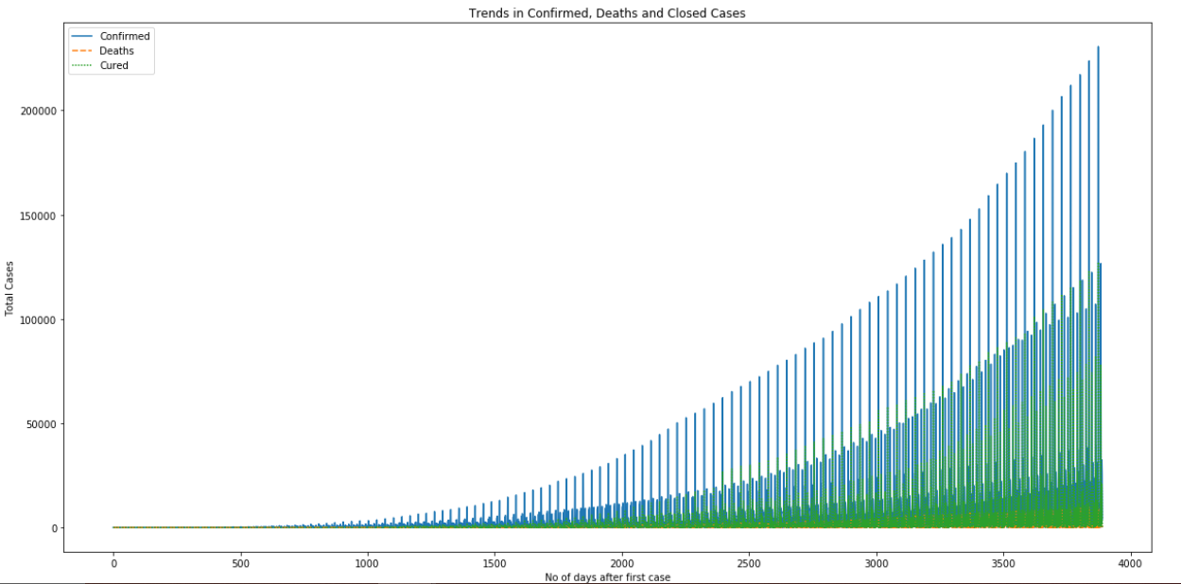

3.2 Tree by plot for Covid-19 India

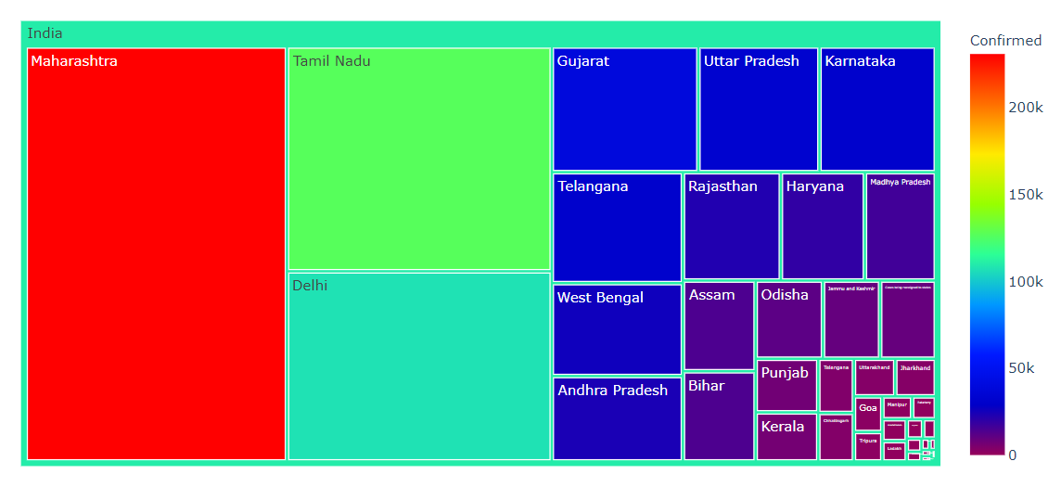

3.3 State wise Insights:

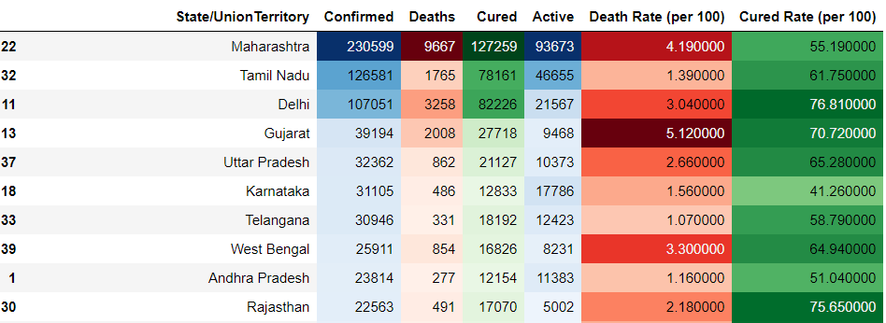

3.4

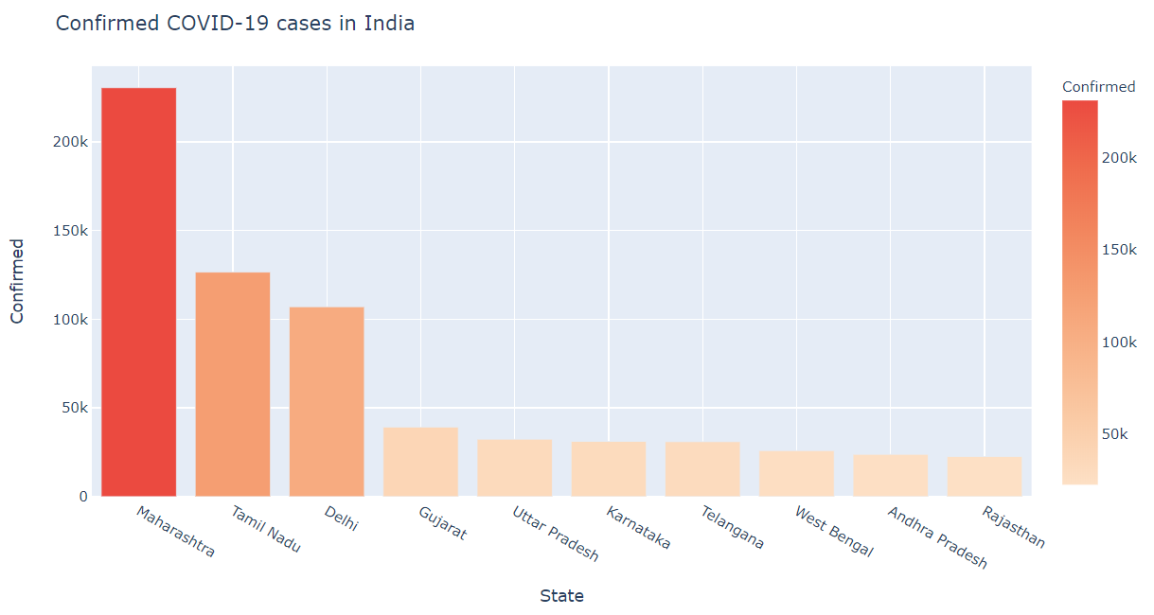

3.5

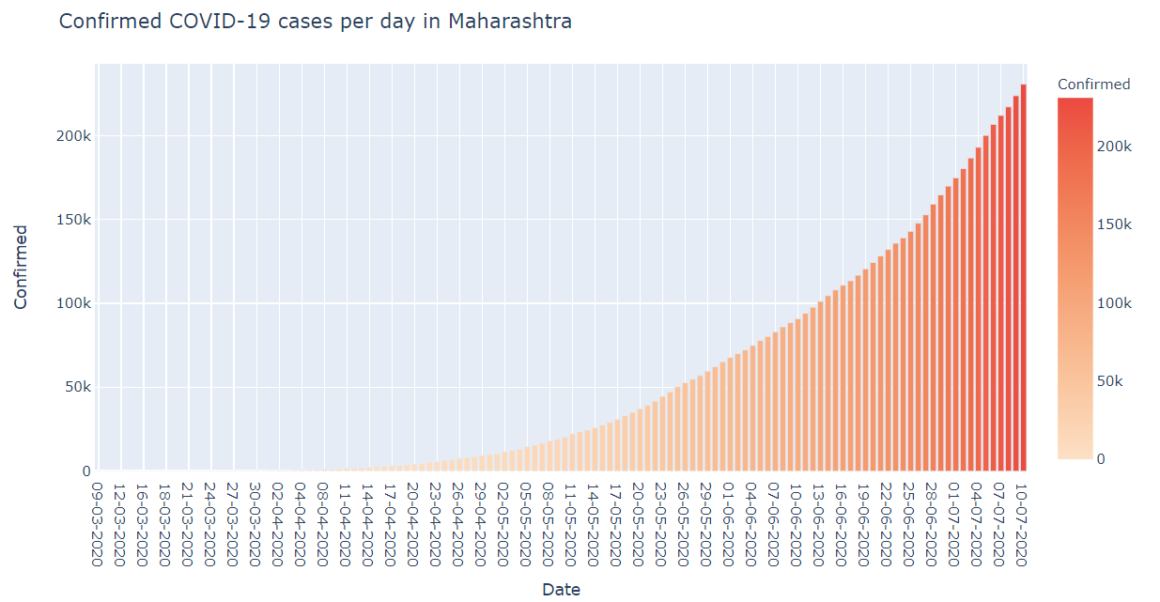

3.6 Time evaluation

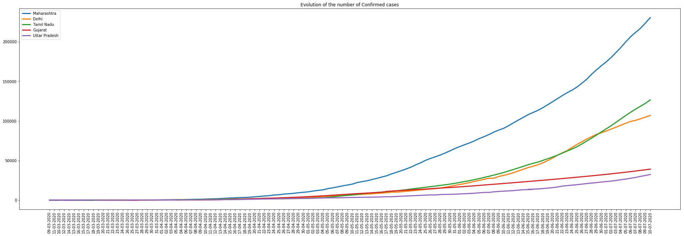

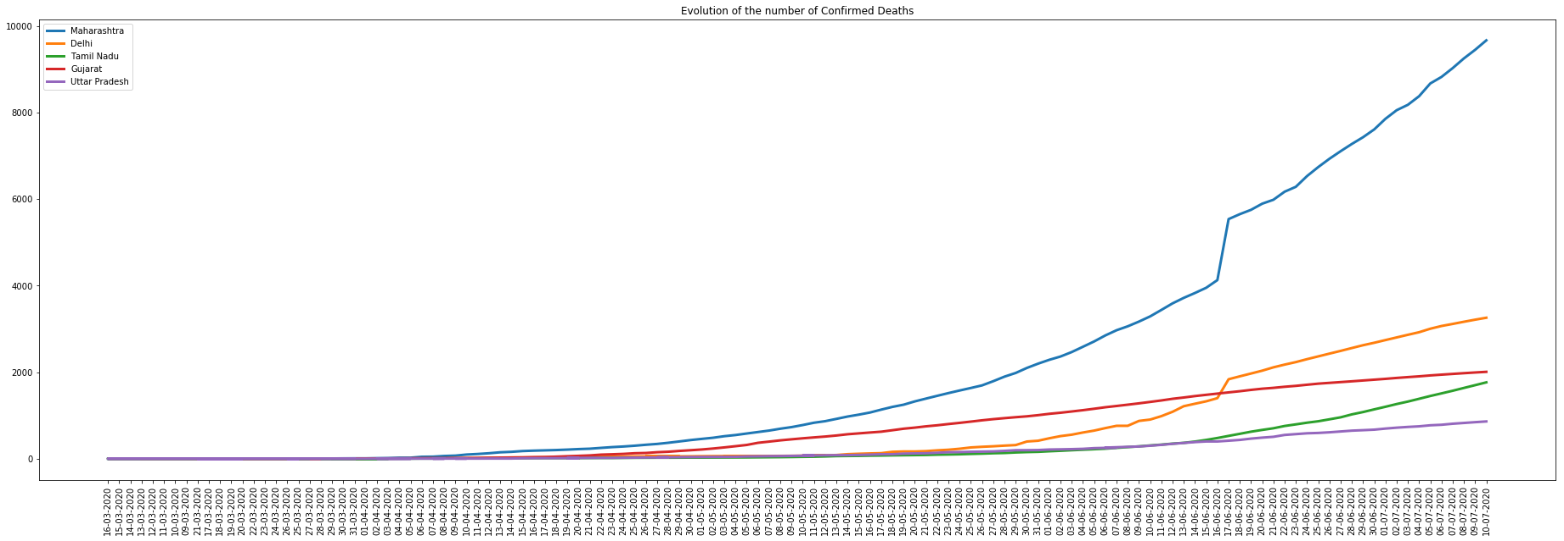

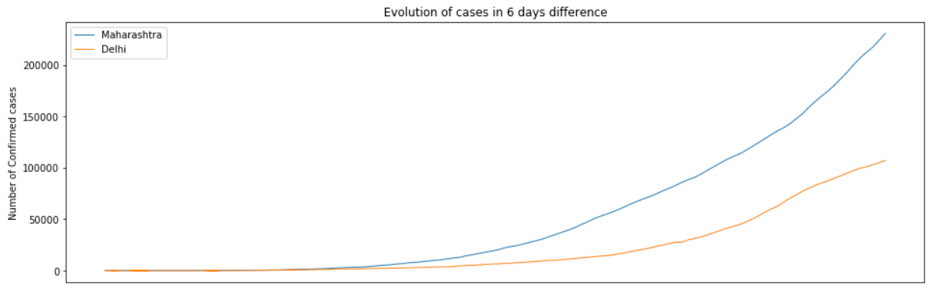

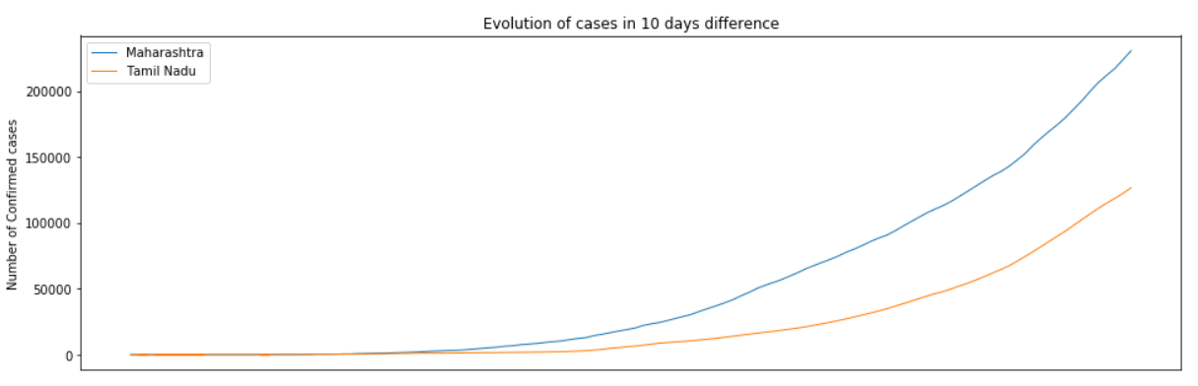

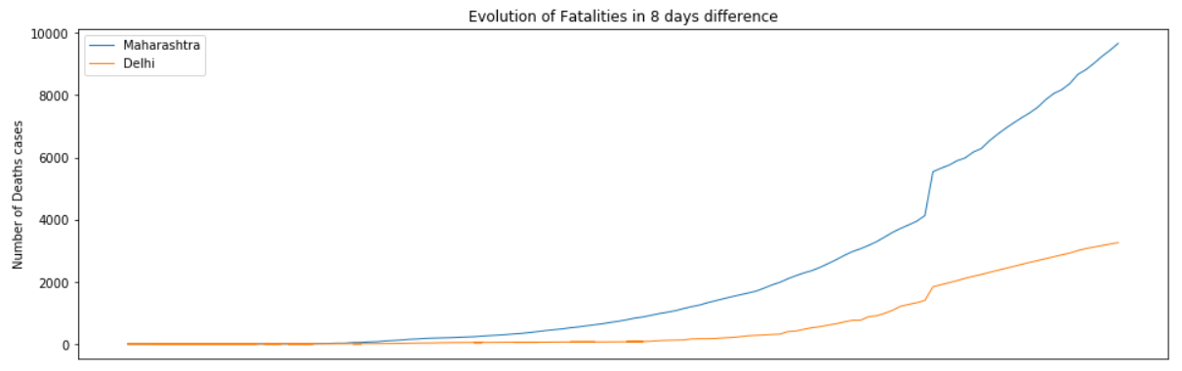

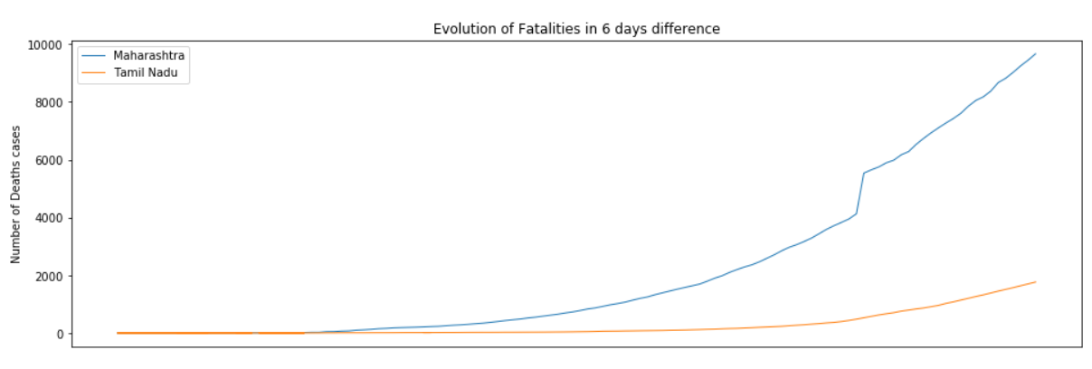

3.7 ARIMA Model

Cases Distribution with Rolling mean and standard deviation

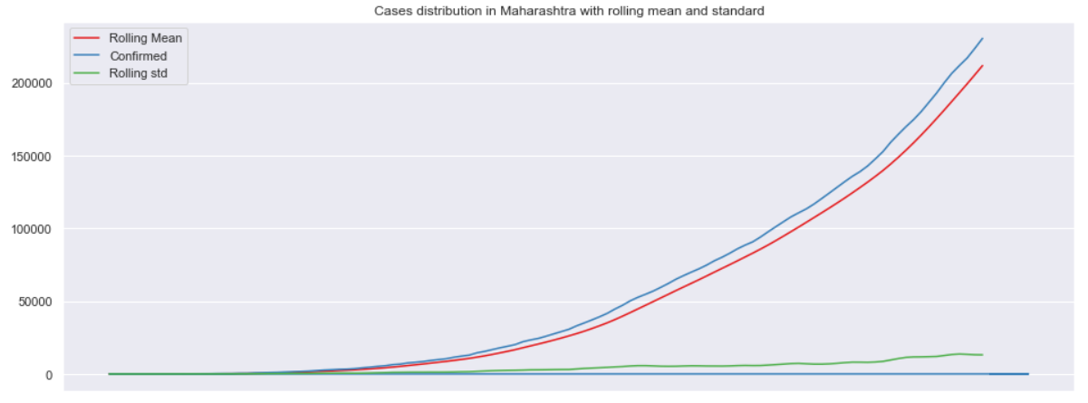

Decomposing the to find its properties

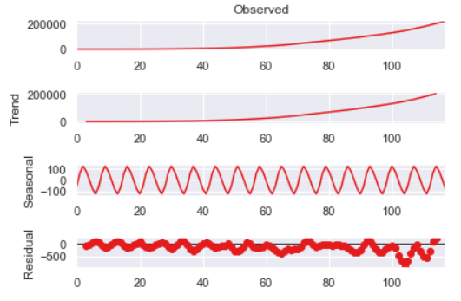

Data Stationarity and transformation

Maharashtra results of Dickey-Fuller Test

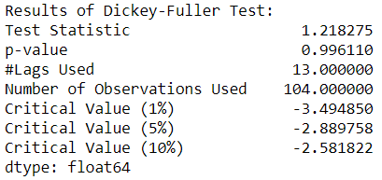

3.7.1 AUTO Correlation

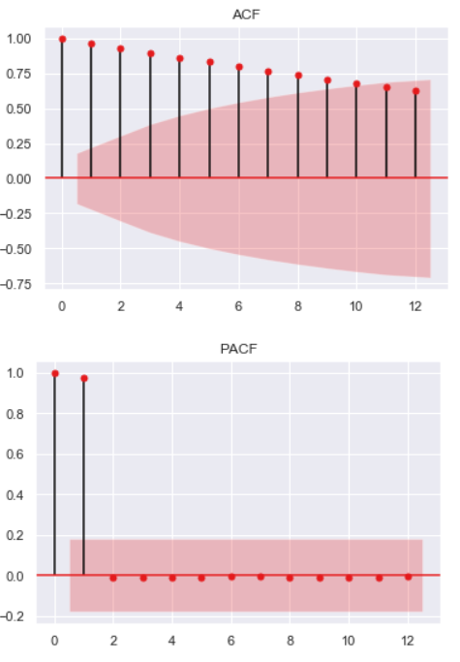

ARIMA Model Building

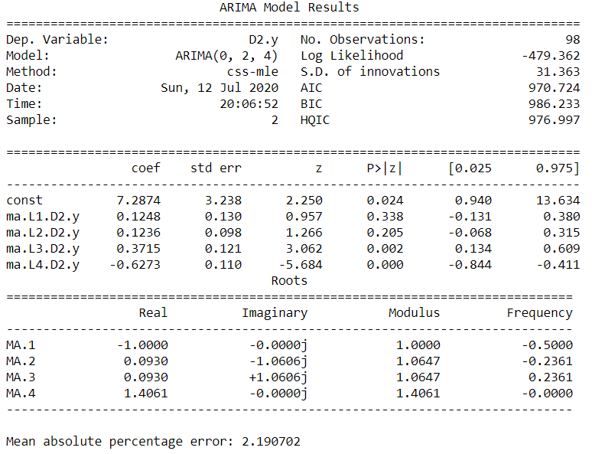

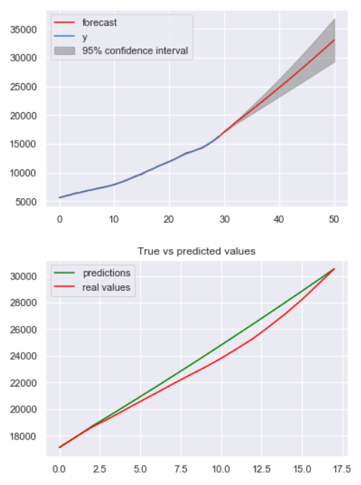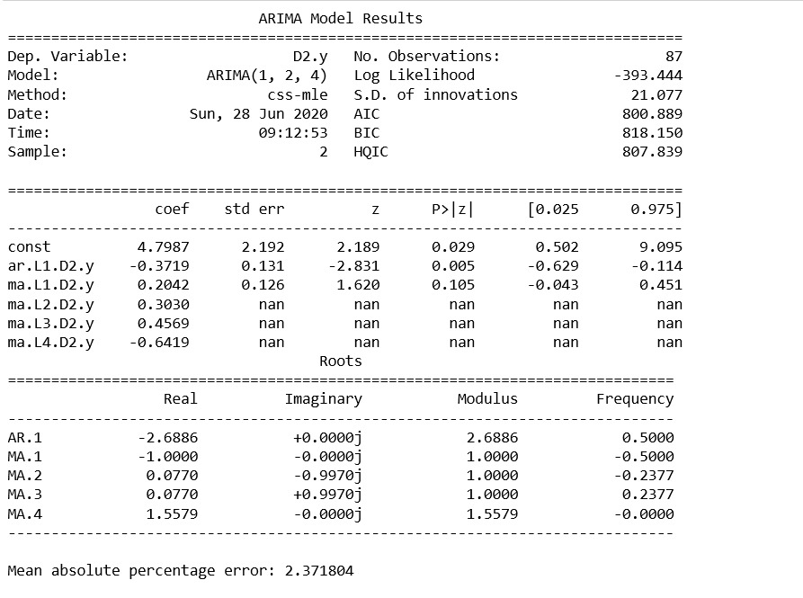

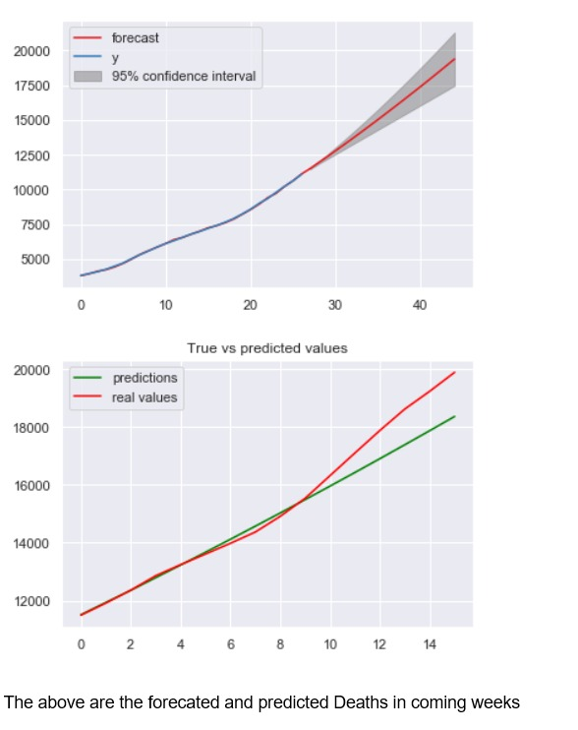

Insights:

The above obtained graphs are Forecasted and predicted cases in coming week

Fig 1(a) & 1(b), shows the ARIMA model fitted correlogram for the active and confirmed cases. In these figures, we see four subfigures which reveal the trend for the earlier and forecasted values for both confirmed and active cases. Forecasting based on PACF and ACF graphs helps to determine parameters p and q. Moreover, the best ARIMA model fit is considered having the lowest Akaike Information Criterion (AIC) value.

Fig 1(a) also shows the fitted model for total confirmed cases with ARIMA (2, 3, 3) having low AIC. With the help of this model, we have predicted future confirmed cases with 95% CI till 15th July 2020. Similarly, for total active cases, we have a suitable model with ARIMA (3, 3, 1) which helps to predict active cases for the same duration.

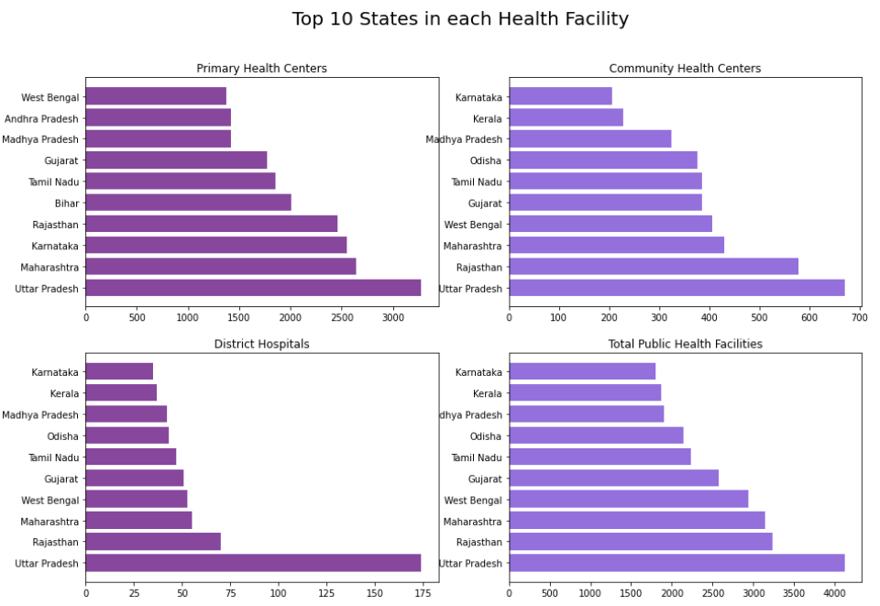

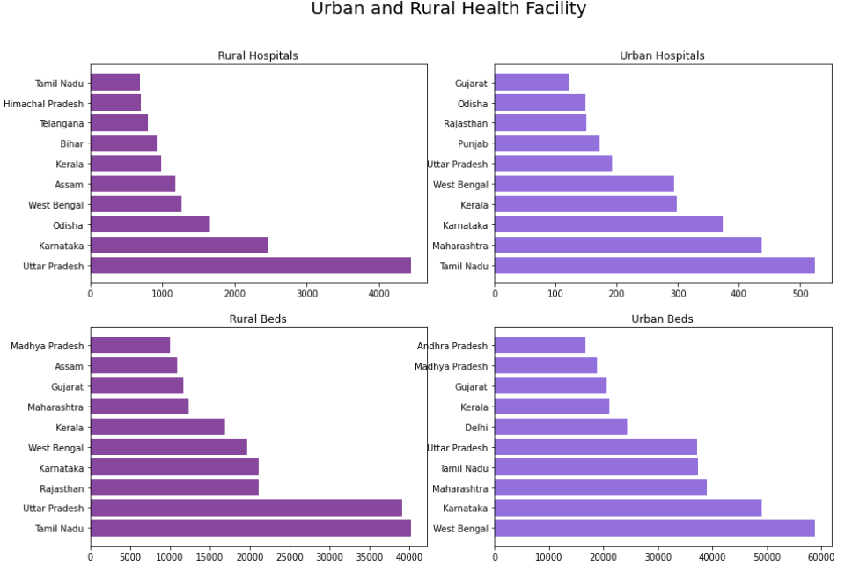

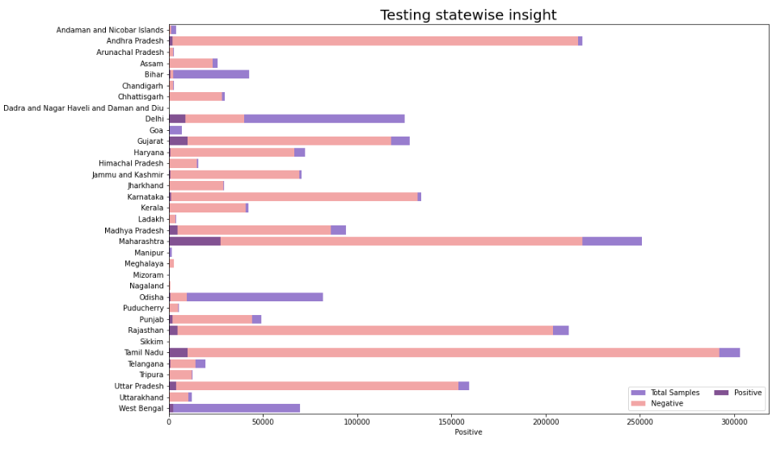

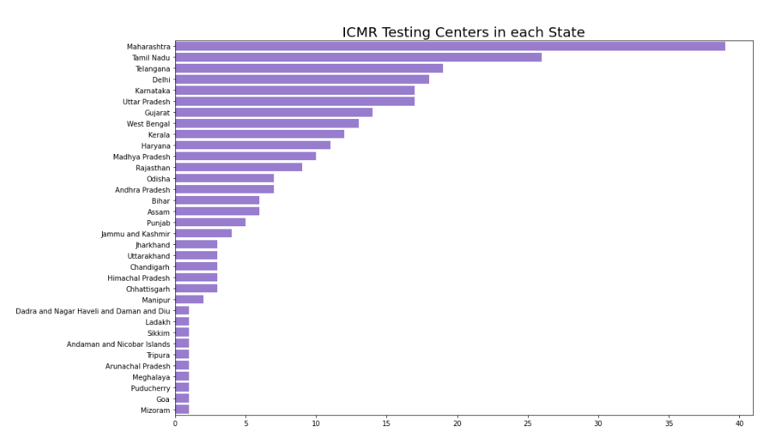

TOTAL BEDS STATE WISE

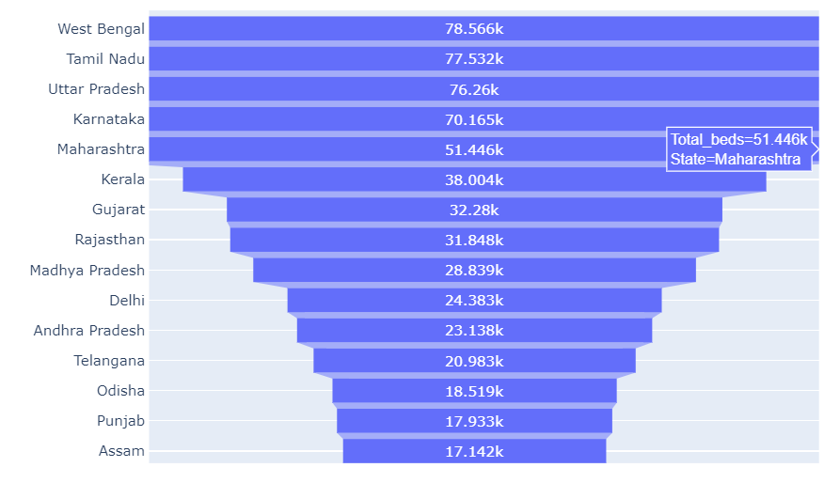

**Tree plot by Total Beds**

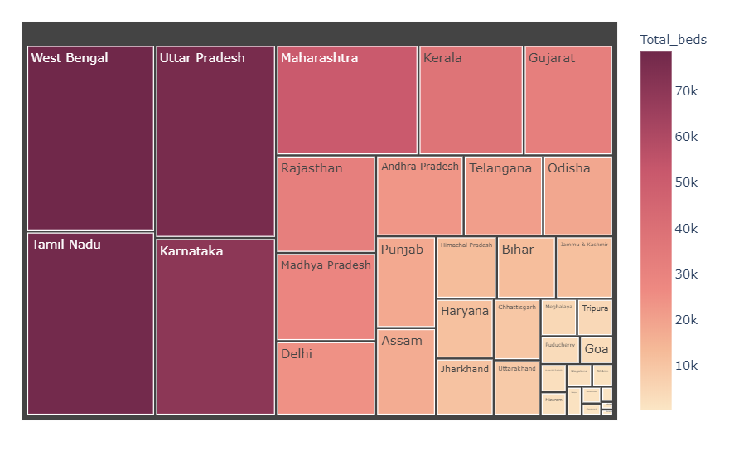

3.6 Estimates of required healthcare infrastructure at state-level

Table 4, 5, and 6 show the required number of isolation beds

**4. Discussion and Conclusion**

Our current forecasts for confirmed and active cases are in line with the actual number of cases. On 2nd June, India has 207,186 confirmed cases, while our forecasts suggested 206,764 confirmed cases (95% CI: 194194, 219334). India had 101,070 active cases on 2nd June, while

our forecasts suggested that India will have 104,526 active cases (95% CI: 96145, 112907). Our results also show that daily confirmed cases will increase at a faster pace as around mid-July India will be getting around 16,000-17,000 daily confirmed cases. By 15th July, we forecast that the total confirmed cases will be around 7.5 lakhs, whereas total active cases will be close to 2.96 lakhs based on our point estimates for India. Maharashtra will be the most affected state even at the 15th July with 1.9 Lakh confirmed cases and 1.15 Lakh active cases while Punjab will be least affected having 2648 confirmed cases and only 115 active cases based on our point estimates. The total number of isolation beds required for India is 2,52,001 (95% CI: 167297, 336706). Our estimates also show that 29,647 ICU beds (95% CI: 19682, 39612) and 14,824 ventilators (95% CI: 9841, 19806) will be required in India by the 15th July. When it comes to states, Maharashtra will be the most affected state and will require 97,642 isolation beds (95% CI: 64862, 130422).

**References:**

5] Tanu Singhal. A review of coronavirus disease-2019 (COVID-19). The Indian Journal of Pediatrics, pages 1–6, 2020.

6] Zunyou Wu and Jennifer M McGoogan. Characteristics of and important lessons from the coronavirus disease 2019 (COVID-19) outbreak in China: summary of a report of 72 314 cases from the chinese center for disease control and prevention.

|  |  |
| --- | --- |
| Trend Analysis and Forecasting of COVID-19 outbreak in India | <https://www.medrxiv.org/content/10.1101/2020.03.26.20044511v1> |
| Intensive care management of coronavirus disease 2019 (COVID-19): challenges and recommendations | <https://www.sciencedirect.com/science/article/pii/S2213260020301612> |
| Critical Care Utilization for the COVID-19 Outbreak in Lombardy, Italy | <https://jamanetwork.com/journals/jama/article-abstract/2763188> |
| SEIR and Regression Model based COVID-19 outbreak predictions in India | <https://arxiv.org/abs/2004.00958> |
| Age-structured impact of social distancing on the COVID-19 epidemic in India | <https://arxiv.org/abs/2003.12055> |
| PREDICTIONS FOR COVID-19 OUTBREAK IN INDIA USING EPIDEMIOLOGICAL MODELS | <https://www.medrxiv.org/content/medrxiv/early/2020/04/06/2020.04.02.20051466.full.pdf> |
| Forecasting COVID 19 growth in India using Susceptible-Infected-Recovered (S.I.R) model | <https://arxiv.org/abs/2004.00696> |
| Projecting Demand-Supply Gap of Hospital Capacity in India in the face of COVID-19 pandemic using Age-Structured Deterministic SEIR model | <https://www.medrxiv.org/content/10.1101/2020.05.14.20100537v1> |
| Predicted Effects of Stopping COVID-19 Lockdown on Italian Hospital Demand | <https://www.cambridge.org/core/journals/disaster-medicine-and-public-health-preparedness/article/predicted-effects-of-stopping-covid19-lockdown-on-italian-hospital-demand/760FB1159CF65A60C36C401DF2955F02> |
| Forecasting the impact of the first wave of the COVID-19 pandemic on hospital demand and deaths for the USA and European Economic Area countries | <https://europepmc.org/article/ppr/ppr155204> |
| COVID-19 Utilization and Resource Visualization Engine (CURVE) to Forecast In-Hospital Resources | <https://www.medrxiv.org/content/10.1101/2020.05.01.20087973v1> |
| Projecting demand for critical care beds during COVID-19 outbreaks in Canada | <https://www.cmaj.ca/content/192/19/E489.short> |
| Modelling to Predict Hospital Bed Requirements for Covid-19 Patients in California | <https://www.medrxiv.org/content/10.1101/2020.05.17.20104919v4> |
| Explainable machine learning models to understand determinants of COVID-19 mortality in the United States | <https://www.medrxiv.org/content/10.1101/2020.05.23.20110189v1> |
| How artificial intelligence and machine learning can help healthcare systems respond to COVID-19 | <https://www.vanderschaar-lab.com/NewWebsite/covid-19/post1/paper.pdf> |
| Prediction models for diagnosis and prognosis of covid-19: systematic review and critical appraisal | <https://www.bmj.com/content/369/bmj.m1328.long> |

**Web-based Sources:**

1. Press Information Bureau (2020). 'PIB'S DAILY BULLETIN ON COVID-19', 11th July.
2. Forecasting COVID-19 cases in India https://towardsdatascience.com/forecastingCOVID-19-cases-in-india-c1c410cfc730